5.2 Project: Comprehensive Final Report

Predicting Heart Disease Risk Using Machine Learning Techniques

Name: Takeria Thomas
Date: 08/27/2026
Student ID: taktho3199

GitHub Repository: https://github.com/taktho3199/heart-disease-risk-prediction

1. Project Overview
Project title: Predicting Heart Disease Risk Using Machine Learning Techniques
Dataset selected: UCI Heart Disease Data
Dataset source: Kaggle - https://www.kaggle.com/datasets/redwankarimsony/heart-disease-data

Problem being investigated: Heart disease is a leading cause of death, and early diagnosis of patients at high risk for heart disease allows for earlier intervention. The project consists of developing and comparing machine-learning models that can predict whether a patient has heart disease based on their routine clinical measurements, followed by testing the predictions of the best model for realism based on simulated changes in the key risk factors.

Research questions:
1. Which patient characteristics have the strongest relationship with heart disease?
2. Does a neural network provide more accurate predictions than a baseline classification model?
3. How do changes in cholesterol, resting blood pressure, maximum heart rate, and exercise-related variables affect predicted heart disease risk?

2. Data Cleaning, EDA, and Preprocessing
The raw data had 16 columns of demographic, clinical, and diagnostic measurements, and 920 patient records. The target was designed by binarising the severity score num (1 = disease, num > 0; 0 = non-disease, num = 0), giving a fairly balanced result of 509 disease and 411 non-disease cases (approximately 55% disease vs 45% non-disease).

Major EDA findings
The distribution of age was approximately symmetric around 54, the distribution of ST depression (oldpeak) was strongly right-skewed, and the distribution of cholesterol was approximately block of impossible zero values. The results of the correlation analysis indicated that with the exception of cholesterol and resting blood pressure, the number of major vessels (ca, +0.46), the ST depression (oldpeak, +0.39) and the maximum heart rate (thalch, -0.39) were the best numeric correlates of the target. Asymptomatic chest pain and exercise-induced angina (about 79% versus 36%) were among the strongest predictors found by categorical analysis.

Missing-data decisions
There were 1759 missing values in the data in 10 columns. Lightly-missing categorical columns (fbs, exang, restecg) were replaced by the mode and heavily-missing columns (ca, slope, thal) were replaced by an explicit “Unknown” category to ensure that every record was represented.Lightly-missing categorical columns (fbs, exang, restecg) were replaced by the mode, while heavily-missing columns (ca, slope, thal) were given an explicit “Unknown” category to ensure that all records were represented.

Outlier decisions
However, clinically implausible extreme values of trestbps, chol, thalch and oldpeak were capped at 1.5×IQR fences instead of being deleted, with 920 (99.0%) of the values remaining.A clinically plausible extreme value was capped at 1.5×IQR fences instead of being deleted, with 920 (99.0%) of the records retained for trestbps, chol, thalch and oldpeak.

Removed fields, encoding, and scaling
The id column (identifier) and num (which indicates the target) were deleted. The categorical predictors were one-hot encoded (drop_first) to create 31 features; the five continuous predictors were standardized. Engineered features, age_group and chol_level, were created and added to the data set to aid interpretation. An original units copy of the data that was cleaned (project_cleaned_data.csv) was also saved for use on the dashboard and analysis of scenarios.

3. Baseline Predictive Model
Model used and why
A baseline classifier was chosen: Decision Tree Classifier (random_state=42). Simple, easy to interpret, no need to tune the mixture of encoded categorical and standardized numeric features and gives a reference point for the neural network. The data was split 80/20 (stratified), giving 736 training and 184 test patients.

Performance
On the test set the tree reached 0.766 accuracy, 0.757 precision, 0.853 recall, and a 0.802 F1-score.

Strengths and weaknesses
It has the best recall for the disease class (it is capable of catching most true disease class cases) and is fully interpretable. Its major drawback is overfitting. It was very deep and it had a perfect 1.00 score on the training data and a score of 0.766 on the test data, so it did not learn anything beyond the training data.

4. Neural Network Design
Architecture
A fully-connected feed-forward network with an input layer of 31 features, a hidden layer of 32 ReLU neurons, a second hidden layer of 16 ReLU neurons and a single sigmoid output neuron (1,569 trainable parameters).

Training process
The network was trained for 100 epochs with the Adam optimizer and using binary cross-entropy as loss function, with 20% of the training data reserved for validation.

Performance and fit
The network obtained 0.804 accuracy, 0.811 precision, 0.843 recall and a 0.827 F1-score on the same test set. The training curves demonstrated good learning by the model (the accuracy increased and the loss decreased overall) and slight overfitting in later epochs (training accuracy peaked at approximately 0.986 and the validation accuracy was 0.811, with the loss increasing from low levels in the earlier epochs and remaining around these low levels through to the end).

Model | Accuracy | Precision | Recall | F1-Score
Baseline (Decision Tree) | 0.766 | 0.757 | 0.853 | 0.802
Neural Network | 0.804 | 0.811 | 0.843 | 0.827

Table-1

Comparison and improvement opportunities
The neural network also achieved superior accuracy, precision and F1-score compared to the baseline, and was more generalisable, with only a slight advantage in recall. Since the classes are balanced, and both false alarm and missed cases are clinically relevant, an increased F1 score is most important here (0.827 vs. 0.802), which is the major improvement of the network. Some opportunities for improvement that were previously identified involve adding early stopping or regularization to prevent the network from overfitting in the later stages of training, and tuning the architecture and training parameters (number of layers, number of neurons, batch size, number of epochs).

5. Scenario Analysis
A what if scenario analysis was performed using the neural network. A Baseline Scenario was created by predicting on the data that was cleaned but not modified, and then three realistic scenarios were created by modifying selected inputs for each and re-predicted following the same preprocessing pipeline. The results are presented in terms of positive (disease) rate predicted and average probability predicted over all patients.

Scenario | Predicted Disease Rate | Avg Probability | Change vs Baseline
Baseline (no change) | 56.2% | 0.556 | -
S1 - Improved CV Health | 45.7% | 0.444 | -10.5 pts
S2 - Worsened Chol & BP | 57.2% | 0.568 | +1.0 pt
S3 - Exercise Stress Present | 66.4% | 0.661 | +10.2 pts

Table-2

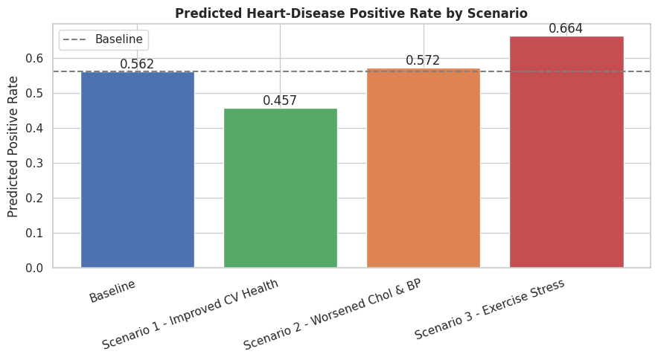
Figure-1

- Baseline Scenario: The network classified the patients as having the disease in approximately 56.2% (average probability 0.556) of the unmodified data.
- Scenario 1 - Improved Cardiovascular Health: The best reductions in the predicted disease rate were with (maximum heart rate +25 bpm, ST depression set to 0, no exercise induced angina) (45.7% (-10.5 points)).
- Scenario 2 - Worsened Cholesterol and Blood Pressure: The smallest change (+1.0 point) was found with the combination (cholesterol +20%, resting blood pressure +15 mmHg).
- Scenario 3 - Exercise Stress Indicators Present: The presence of exercise-induced angina and the presence of ST depression +1.5 increased the predicted disease rate the most, to 66.4% (+10.2 points).
- Most important findings and limitations: The exercise- and heart-rate-related scenarios (1 and 3) shifted the model significantly more than the cholesterol/blood-pressure scenario (2) did, and in all cases, the shift of the model was in the same direction as the shift in predicted risk. These are model sensitivity results: results of the network's predictions that held when inputs of the network were changed, but are not by themselves evidence that the same changes would lead to the same results in real patients. Furthermore, the scenarios were applied equally across all patients and the data are skewed towards males and limited to four hospitals, meaning that the results may not be generalizable.

6. Conclusions and Recommendations
Research Question 1: In both models (and also in the scenario analysis), the features related to exercise (exercise-induced angina, ST depression), the highest heart rate and the number of major vessels were the strongest signals, while cholesterol and resting blood pressure were weak by themselves.
Research Question 2: The neural network achieved better accuracy: 0.766 to 0.804, and F1-score: 0.802 to 0.827, and better generalization compared to the baseline decision-tree.
Research Question 3: The scenario analysis demonstrated that the model's prediction of risk is very sensitive to exercise and heart rate features and combinations of favorable changes and only marginally sensitive to cholesterol and blood pressure alone.
Recommendations
In this dataset, the most important screening signals are exercise-related ones, which are also the most important signals in any risk tool developed on the basis of these data, and deserve special attention. The suggested model is a neural network, which is enabled by early stopping or regularization to prevent overfitting before any use. All conclusions are associational; the model is to be used as a decision support tool, not a diagnostic or causal tool and should be validated on expanded, more representative data prior to clinical use.

GitHub repository: https://github.com/taktho3199/heart-disease-risk-prediction

Dashboard Appendix
The Power BI dashboard along with new scenario-analysis visualizations in Part 5 are documented in this appendix. The Part 4 figures (Target distribution, Feature relationships and Model comparison) remain the same, and the results from the scenarios are presented below.

Figure A1. Full Updated Dashboard

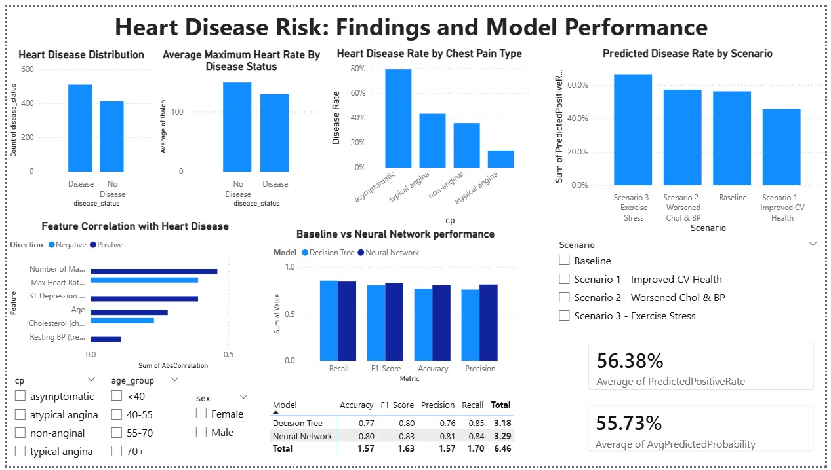

Description: The entire dashboard, with the Part 4 EDA and model visualization still present and the new scenario-analysis panel added.
Significance: Displays the complete analytical narrative in one view for the general public.
Key Insight: The interactive scenario control allows a viewer to watch the predicted risk change from the baseline when inputs are changed.

Figure A2. Predicted Disease Rate by Scenario

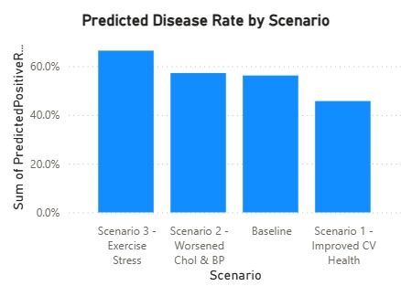

Description: Predicted disease rate compared on a bar chart for the Baseline and three scenarios.
Significance: Answers Research Question 3 directly and demonstrates the response of predicted risk to variation of inputs.
Key Insight: Cardiovascular health improvements have the greatest impact (predicted risk of about 46%) and exercise stress has the largest impact (predicted risk of about 66%), with little effect from changes in cholesterol/blood pressure.

Figure A3. Scenario Detail Card (Interactive)

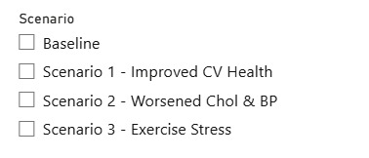

Description: A card depicting the expected disease rate and average chance of the chosen scenario in the Scenario slicer.
Significance: Shows the interaction needed visual changes as the viewer clicks Baseline, Scenario 1, 2, 3.
Key Insight: Allows a viewer to access the exact foreseen risk for any particular scenario on demand.

